Low Level Design

Airport Data Analysis

|  |  |
| --- | --- |
| Written By | Sanjesh Chourasia |
| Document Version | 0.1 |
| Last Revised Date |  |

**DOCUMENT CONTROL**

**Change Record:**

|  |  |  |  |
| --- | --- | --- | --- |
| VERSION | DATE | AUTHOR | COMMENTS |
|  |  |  |  |
|  |  |  |  |
|  |  |  |  |
|  |  |  |  |

**Reviews:**

|  |  |  |  |
| --- | --- | --- | --- |
| VERSION | DATE | AUTHOR | COMMENTS |
|  |  |  |  |

**Approval Status:**

|  |  |  |  |  |
| --- | --- | --- | --- | --- |
| VERSION | REVIEW  DATE | REVIEWED BY | APPROVED BY | COMMENTS |
|  |  |  |  |  |

**Contents**

**1. Introduction** 3

**1.1 What is Low Level design document?** 3

**1.2 Scope** 3

**2. Architecture** 4

**3. Architecture Description** 6

**3.1. Data Description** 6

**3.2 Deployment** 7

# **1. Introduction**

## **1.1 What is Low Level design document?**

The goal of the LDD or Low-level design document (LLDD) is to give the internal logic design of the actual program code for the House Price Prediction dashboard. LDD describes the class diagrams with the methods and relations between classes and program specs. It describes the modules so that the programmer can directly code the program from the document.

## **1.2 Scope**

Low-level design (LLD) is a component-level design process that follows a step-by-step refinement process. The process can be used for designing data structures, required software architecture, source code, and ultimately, performance algorithms. Overall, the data organization may be defined during requirement analysis and then refined during data design work.

# **2. Architecture**

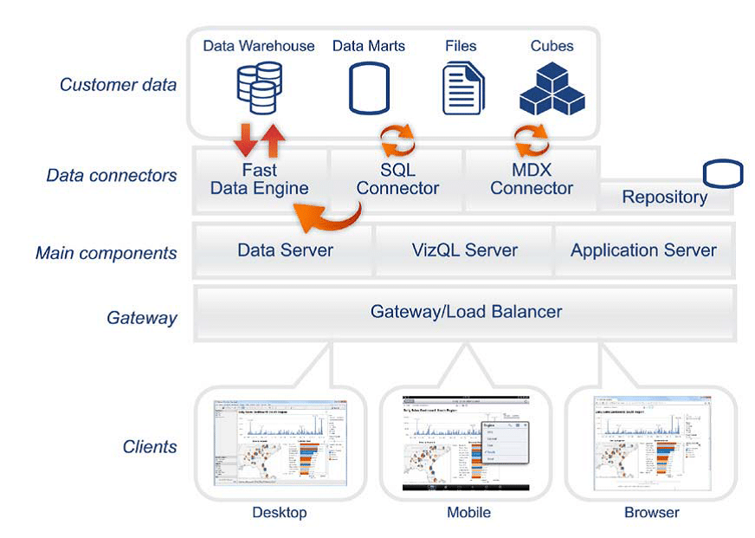

Tableau Server Architecture

Tableau Server is an important component in Tableau architecture as it is thoughtfully designed to manage and execute crucial processes. It is important for us to understand what’s under the hood of Tableau Server as it is a core component and helps to understand Tableau better.  
Let us go through the components of Tableau Server and learn how they work.

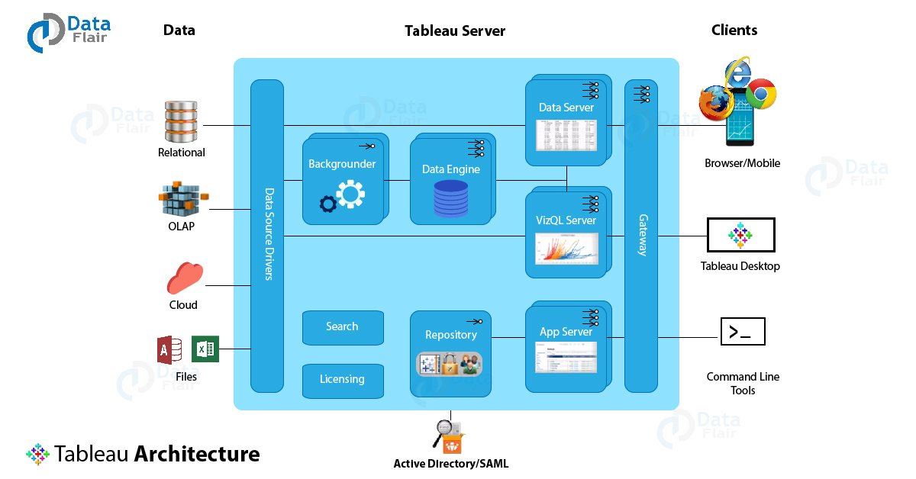

1. Gateway/Load Balancer: -

It acts as an Entry gate to the Tableau Server and also balances the load to the Server if multiple processes are configured.

2. Application Server: -

Application Server processes (wgserver.exe) handle browsing and permissions for the Tableau Server web and mobile interfaces. When a user opens a view on a client device, that user starts a session on Tableau Server. This means that an Application Server thread starts and checks the permissions for that user and that view.

3. Repository: -

Tableau Server Repository is a PostgreSQL database that stores server data. This data includes information about Tableau Server users, groups and group assignments, permissions, projects, data sources, and extract metadata and refresh information.

4. VIZQL Server: -

Once a view is opened, the client sends a request to the VizQL process (vizqlserver.exe). The VizQL process then sends queries directly to the data source, returning a result set that is rendered as images and presented to the user. Each VizQL Server has its own cache that can be shared across multiple users.

5. Data Engine: -

It Stores data extracts and answers queries.

6. Backgrounder: -

The backgrounder executes server tasks which include refreshing scheduled extracts, tasks

initiated from tabcmd and manages other background tasks.

7. Data Server: -

Data Server Manages connections to Tableau Server data sources. It also maintains metadata from Tableau Desktop, such as calculations, definitions, and groups.

8. Tableau Communication Flow: -

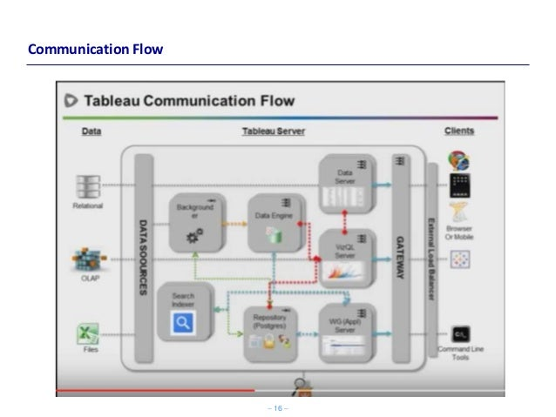

# **3. Architecture Description**

## **3.1. Data Description**

This dataset contains detail about the Airport data set. I am using this dataset for my analysis.

You can find the dataset on the given link [https://drive.google.com/drive/folders/1G2fQ6_lDcToyROYbszILP6uwbJrvPu6?usp=sh](air%20travel%20dataset.xlsx)

This data set contains Date, Geometry, Route, Route 1, Route 2, Event, Flight No, and Gate columns.

## **3.2 Deployment**

Tableau’s analytics platform offers three different deployment options depending on your environment and needs. The below graphic shows each option at a glance:

1. Tableau Online Get up and running quickly with no hardware required. Tableau Online is fully hosted by Tableau so all upgrades and maintenance are automatically managed for you.

2. Tableau Server deployed on public cloud: Leverage the flexibility and scalability of cloud infrastructure without giving up control. Deploy to Amazon Web Services, Google Cloud Platform or Microsoft Azure infrastructure to quickly get started with Tableau Server (on your choice of Windows or Linux). Bring your own license or purchase on your preferred marketplace.

3. Tableau Server deployed on-premises: Manage and scale your own hardware and software (whether Windows or Linux) as needed. Customize your deployment as you see fit.

.